Note: This is a game I created in college. Feel free to share under Creative Commons. Thanks, Keith Hackbarth, RentersFriend.com

UCSD Ultimate – Beta Test 2

This is still just a beta test of the game. To install unzip all files into a folder.
→I need big time help with all aspects of the game (drawing higher quality graphics, recording sounds, programming!, etc.) if anyone has time available. I also need recommendations on how to actually make the game playable. Obviously, it needs the guys to stack, do world's greatest, stall count, etc... but I need specific ideas such as <what buttons will do what><how to do the graphics>.
email me:keithhackbarth@yahoo.com with ideas, comments, bug-reports;

Current improvements: sound effects when catching / throwing
disc returns to where it went out of bounds
improved throwing system
players can jump

As of now its only a 2 player game. I included the keyboard controls although this is what I’ve been leaning towards for these controls on the game pad. Use the numpad for the numbers with the numlock on.

Buttons: C or 9
If throw has been caught, hold down for varying powers of a high release or huck.
If disc is in air, jump.

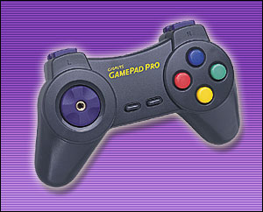

Buttons: X or 8
If throw has been caught, hold down for varying powers of a low throw or a dump.
*If disc is in air, lay out.
*Can’t lay out in this version

Buttons: Z or 7
Select next player.

Buttons: V or 0
*Turbo
*Can’t use turbo in this version

Buttons: Arrow Keys or 1,5,2,3 on numpad
Movement of selected player or direction of throw

For those of you who have asked, I got the characters from the old school new World Cup Soccer and the other graphics are done with cmu graphics ☹.

